Project Design Phase-II

Data Flow Diagram & User Stories

|  |  |
| --- | --- |
| Date | 16 October 2022 |
| Team ID | PNT2022TMID42038 |
| Project Name | Real-Time River Water Quality Monitoring and Control System |
| Maximum Marks | 4 Marks |

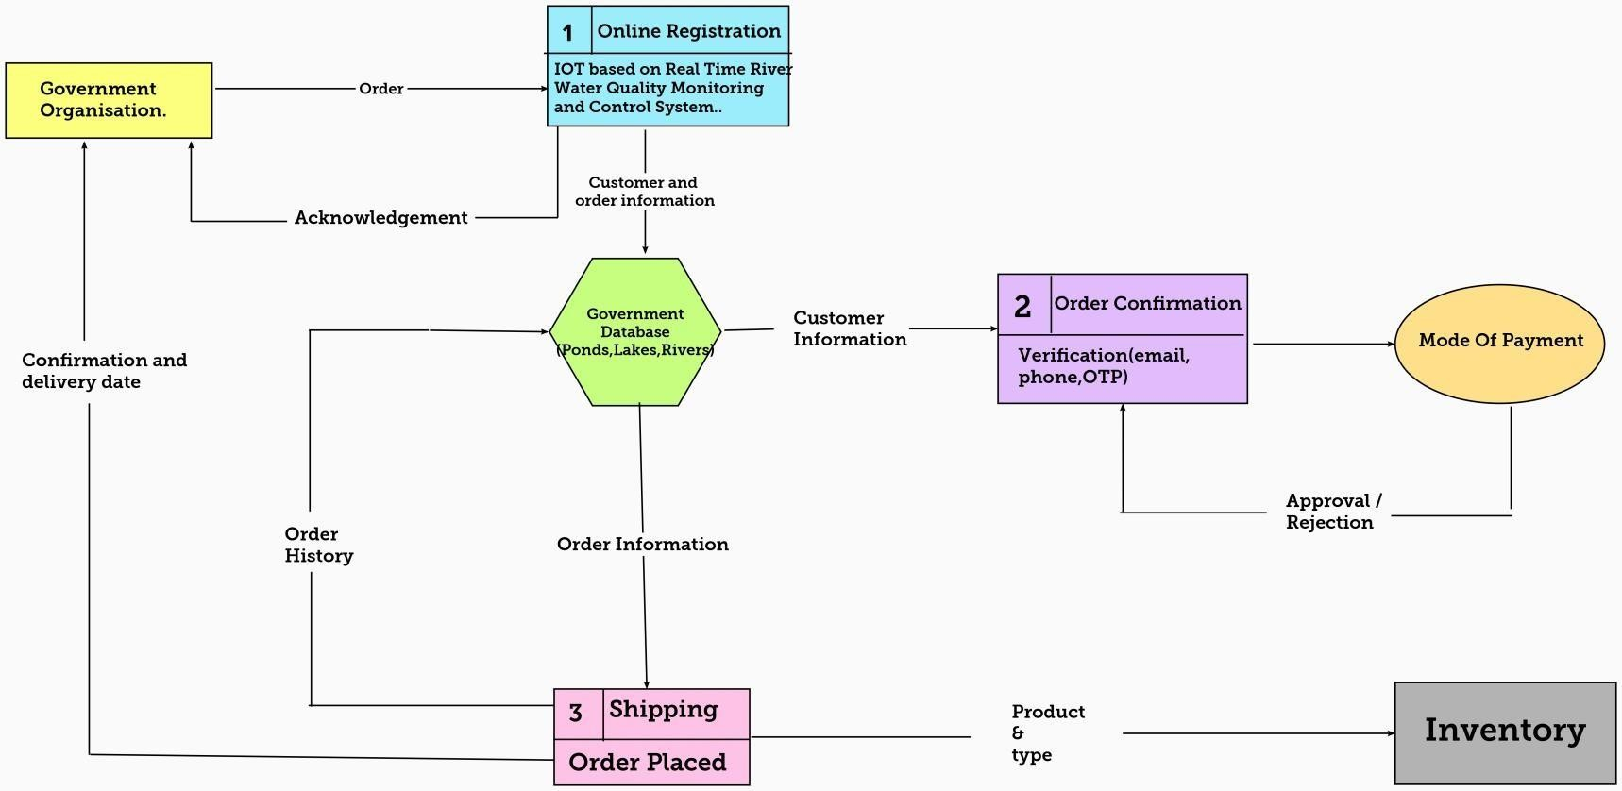

User Stories

|  |  |  |  |  |  |  |
| --- | --- | --- | --- | --- | --- | --- |
| **User Type** | **Functional**  **Requirement (Epic)** | **User**  **Story Number** | **User Story / Task** | **Acceptance criteria** | **Priority** | **Release** |
| Customer (Mobile user) | Registration | USN-1 | As a user, I can register for the application by entering email, password, and  confirming my password. | They can access my account/dashboard | HIGH | SPRINT-1 |
|  |  | USN-2 | As a user, I will receive a confirmation email once I have registered for the  application | They can receive e confirmation email &  click confirm | HIGH | SPRINT-2 |
|  |  | USN-3 | As a user, I can register for the application through Google | They can register & access the dashboard  with Google | HIGH | SPRINT-1 |
|  |  | USN-4 | As a user, I can register for the application through Gmail | They can register through the mail. | MEDIUM | SPRINT-2 |
|  | Login | USN-5 | As a user, I can log into the application by entering email, password & captcha | They can receive login credentials. | HIGH | SPRINT-1 |
|  | Interface | USN-6 | As a user, the interface should be user- friendly manner | They can able to access easily. | MEDIUM | SPRINT-1 |
| Customer (Web user) | Dashboard | USN-7 | As a user, I can access the specific info(ph value, temp, humidity, quality). | They can able to know the quality of the water | HIGH | SPRINT-1 |
| Customer (input) | View manner | USN-8 | As a user, I can view data in visual representation manner(graph) | They can easily understand by visuals. | HIGH | SPRINT-1 |
|  | Taste | USN-9 | As a user , I can able to view the quality(salty) of the water | They can easily know whether it is salty or not | HIGH | SPRINT-1 |
|  | Colour visibility | USN-10 | As a user , I can able predict the water colour | Thry can easily know the condition by colour | HIGH | SPRINT-1 |
| Administrator | Risk tolerant | USN-11 | An administrator who Is handling the  system should update and take care of the application | Admin should monitor the records properly. | MEDIUM | SPRINT-3 |